RIMPAC
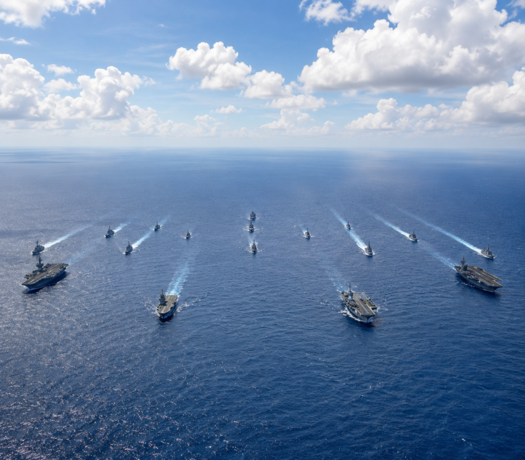
RIMPAC (Rim of the Pacific) is the world's largest international naval exercise. It is conducted every two years near the Hawaiian Islands of the United States. The exercise involves the participation of the navies of several countries with their warships, submarines, aircraft, and military personnel. Its objective is to enhance maritime security, conduct joint military exercises, and strengthen preparedness for disaster relief, search and rescue, and maritime threats. RIMPAC 2026 includes the participation of more than 30,000 military personnel, 30 countries, more than 30 warships, 5 submarines, and over 200 aircraft. India is also a regular participant in the exercise.
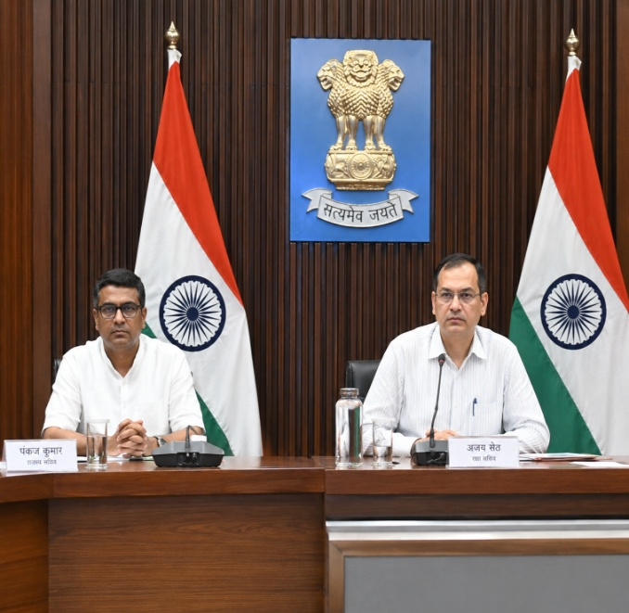
Haryana–Rajasthan Yamuna Water Agreement
Haryana and Rajasthan reached an agreement to resolve the nearly 30-year-old Yamuna water dispute. Both states agreed to implement the 1994 Upper Yamuna River Board Agreement. Under this agreement, Rajasthan will receive its allocated share of water from the Hathni Kund Barrage during the non-monsoon period through an underground pipeline.
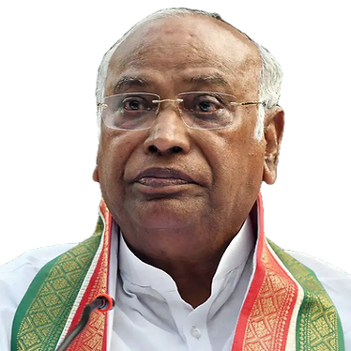
Leader of the Opposition in the Rajya Sabha: Mallikarjun Kharge
Congress President Mallikarjun Kharge has once again been appointed as the Leader of the Opposition in the Rajya Sabha. Rajya Sabha Chairman C.P. Radhakrishnan administered the oath to him and seven other newly elected members. Meanwhile, Rahul Gandhi has been serving as the Leader of the Opposition in the Lok Sabha since June 2024.

'Aarogya Setu 2.0' App Launched
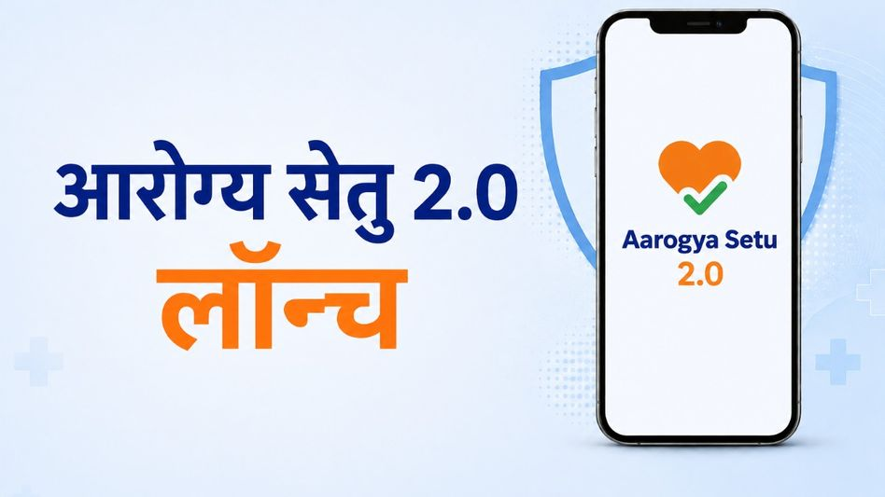
The Ministry of Health and Family Welfare has launched the Aarogya Setu 2.0 app. It will now also function as a digital platform for Personal Health Records. The app includes the PM-JAY Wallet, enabling Ayushman Bharat beneficiaries to view their insurance coverage and claim information. It will also make it easier to create an ABHA ID, upload laboratory reports, and complete digital registration at hospitals.

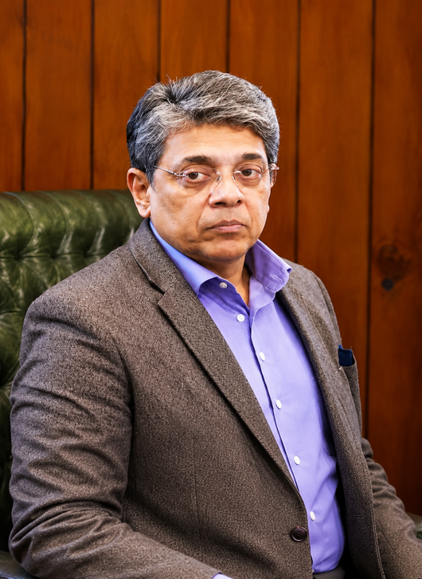
Mahesh Dixit Takes Charge as Director of the Intelligence Bureau
Senior IPS officer Mahesh Dixit assumed charge as the new Director of the Intelligence Bureau on Tuesday. He succeeds Tapan Kumar Deka, who retired after completing a four-year tenure. Dixit is a 1993-batch IPS officer. He originally belongs to the Andhra Pradesh cadre and is currently serving in the Telangana cadre.

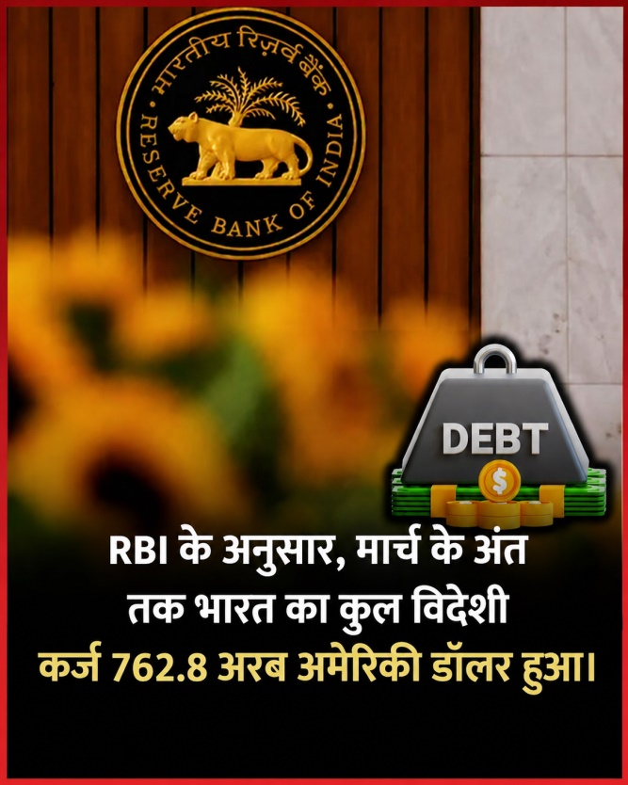
India's Total External Debt Reaches US$ 762.8 Billion: Latest RBI Data
According to the Reserve Bank of India (RBI), India's total external debt stood at US$ 762.8 billion at the end of March. This is US$ 26.3 billion higher than the previous year. The ratio of external debt to GDP increased to 20.8%, compared to 19.8% a year earlier. The US dollar accounted for the largest share of the total external debt at 55.5%. Loans constituted the largest component of the debt at 34.7%, followed by currency and deposits at 22.3%.

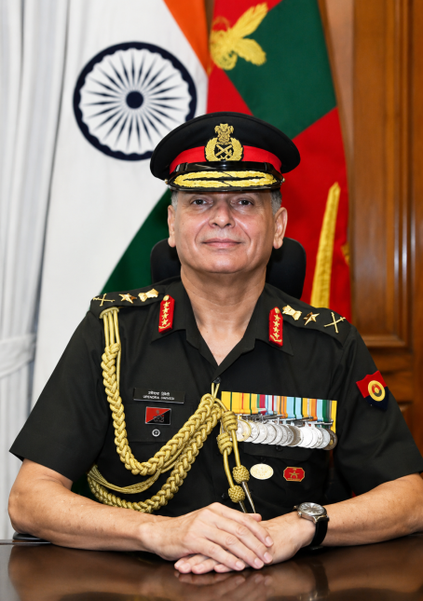
General Dheeraj Seth Assumes Charge as the 31st Chief of the Army Staff
General Dheeraj Seth assumed charge as the 31st Chief of the Army Staff on Tuesday. He succeeded General Upendra Dwivedi, who retired after completing 40 years of service. Seth is an alumnus of the National Defence Academy (NDA) and was commissioned into the Armoured Corps in 1986. He has also served as the Vice Chief of the Army Staff. He has experience in commanding the South Western Command and the Southern Command.

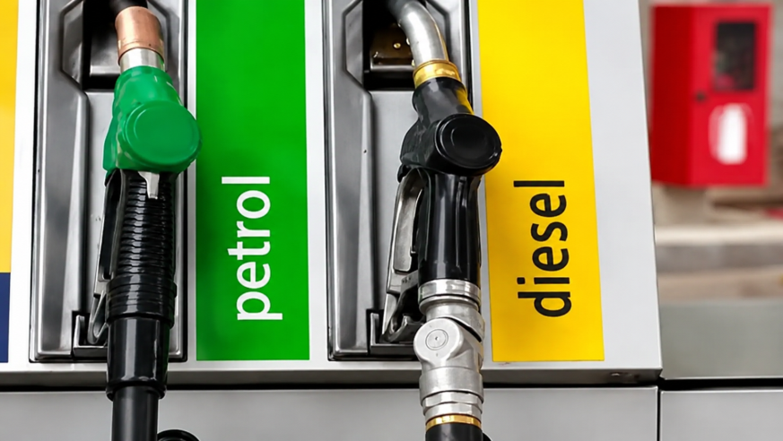
Export Duty Reduced on Diesel and ATF, Increased on Petrol
Following the decline in global oil prices, the Central Government has reduced the windfall tax (export duty) on the export of diesel and Aviation Turbine Fuel (ATF). The export duty on diesel has been reduced from ₹14 to ₹8.5 per litre, and on ATF from ₹12.5 to ₹7.5 per litre. The export duty on petrol has been increased from ₹1.5 to ₹4 per litre to ensure domestic supply. The revised rates will come into effect from Wednesday.
Windfall Tax
Windfall Tax, also known as an "unexpected profit tax," is an additional tax (or special levy) imposed by the government on a particular industry or company when it earns exceptionally high and unexpected profits due to a sudden or unusual event.
Such profits are not the result of the company's outstanding performance or innovation, but arise because of external circumstances such as war, a global crisis, or inflation, which are beyond the company's control.

